Use the labels from the list below to fill in the boxes:
Rows, Columns, Cell, Input Cell, Cell Reference
3.
5.
2.
1.
4.

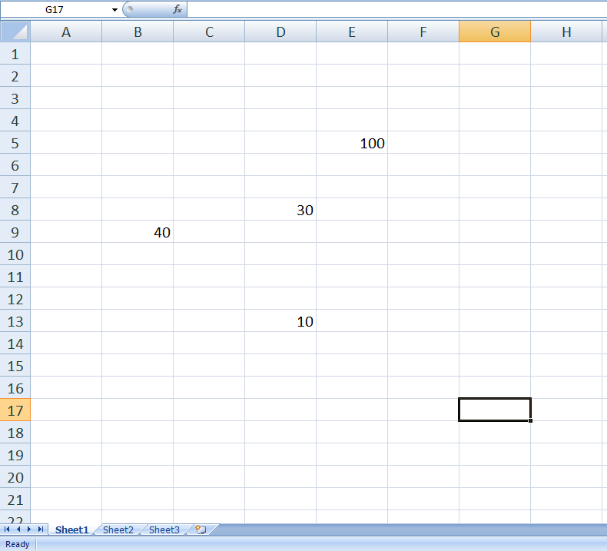

6. What is the value in cell D13? _____________
7. What is the value in cell E5? ______________

